Hospital Patient Management System Report
Id:2312190
Introduction:
This project is a Hospital Patient Management System developed using Object-Oriented Programming (OOP) in Python. The system is designed to manage patients, doctors, appointments, and billing in an organized way.
The main goal of this project is to apply core OOP concepts such as inheritance, abstraction, polymorphism, encapsulation, and composition in a real-world scenario. The system allows users to register patients (both InPatient and OutPatient), add doctors, book appointments, and calculate bills.
Overall, this project demonstrates how OOP can be used to build a modular, reusable, and maintainable system

Class Diagram:

The system consists of six classes:
Person, Patient (abstract), InPatient, OutPatient, Doctor, and Hospital. Patient and Doctor inherit from Person. InPatient and OutPatient inherit from Patient. Hospital manages patients and doctors, showing composition. Compared to the initial design, the final version includes working appointment handling and operator overloading.
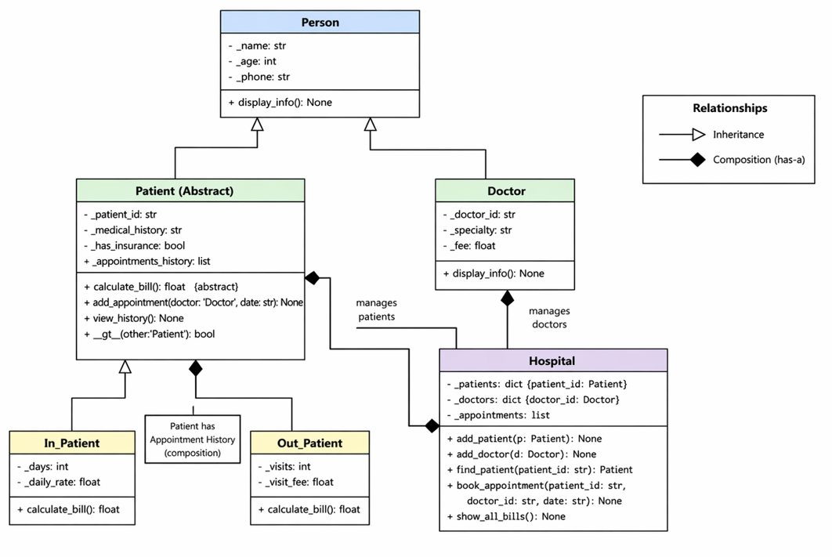

Changes from week 2 Design checkpoint:
1. Added attribute _appointments_history and methods add_appointment() and view_history() in Patient class to store and manage appointment history.
2. Added attribute _has_insurance in Patient class for insurance discount feature.
3. Added method __gt__() in Patient class for operator overloading to compare patients by bill.
4. Detailed attributes and methods for all classes as per final implementation.

2. OOP Concepts Explanation

- Classes & Objects
-Class is a blueprint (like a template) and Object is the real thing created from that class.
-Used in all .py files (line ~20–60)
-Used to represent real entities
- Encapsulation
-It means hiding data using private variables (_name, _id)
-Used in all classes. Ex: _name, _patient_id
-Used to protect data so it can’t be directly accessed or changed

- Inheritance
-It means one class takes properties from another.
-Used in Person→Patient/Doctor, Patient→InPatient(line 6)/OutPatient(line 6)
-Used to reuse data

- Polymorphism
-Polymorphism means one function works differently depending on the object. Same method but different behavior.
-Used in calculate_bill() in inpatient(line ~10), Outpatient(line ~10),
-Used to get same method but different rule in other class

- Abstraction
-Hiding implementation, showing only necessary part. It means we define what we do, but not how to do it.
-Used in patient.py (ABC) (line ~1–15)
-Used for enforce method implementation.

- Composition
-It means a class has objects of another class (has-a relationship)
- Used in hospital.py lists (line ~2–6)
-Used because it has-a relationship with patient and doctor

- Operator Overloading
-Operator overloading allows us to use operators with custom objects. Changing meaning of operators like >, +
-Used in __gt__ in patient.py(line 25)
-Used to compare bills.

- Exception Handling
-Exception handling is used to prevent program crash and handle errors safely. Handling errors using try-except
-Used in hospital.py(line 22), exceptions.py
-Used to handle errors

3. Chosen Features

- Feature A: Insurance Discount
User: reduces bill.
Implementation: calculate_bill() applies 20% discount.
Patients with insurance get 20% discount in calculate_bill().
- Feature F: Appointment History
User: track past visits.
Implementation: stored in Patient, updated in Hospital.
Appointments stored in Patient class and updated in Hospital.

